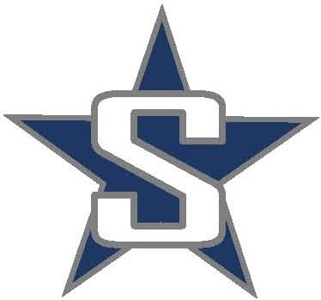
SOLDOTNA HIGH SCHOOL
NORDIC SKI 2019-20

10/30/2019 Wed Nordic Ski Begins
11/27/2019 Wed Turkey Skate
12/13-14/2019 Fri-Sat @ Dimond Lynx Loppet
12/20/2019 Fri SOHI Candy Cane Scramble
12/21-22/2019 Sat-Sun Besh Cup
1/10-11/2020 Fri-Sat @ Palmer
1/17-18/2020 Sat-Sun Besh Cup
1/24/2020 Fri @ Kenai Klassic
1/25/2020 Sat @ Seward Invite
1/31/2020 Fri @ Homer Invite
2/1-2/2020 Sat-Sun Besh Cup
2/7-8/2020 Fri-Sat @ Mat-Su Invite (Colony)
2/14-15/2020 Fri-Sat @ Region III Championships (Homer)
2/22/2020 Sat @ Borough Championships (Kenai)
2/27-29/2020 Thurs-Sat @ State Championships (Kincaid Trails - Anchorage)

*Besh Cup races are optional and not part of the regular high school race schedule. They are however a great opportunity to race against other top skiers in the state and are Alaska’s current qualifiers for Junior Nationals and Artic Winter Games.

