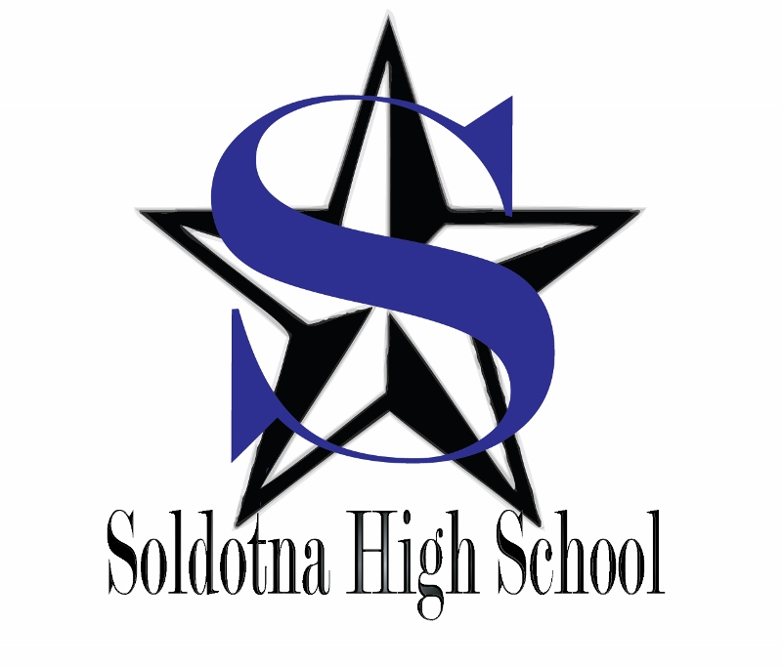

2019-2020

Registration and Enrollment Guide

TABLE OF CONTENTS

Courses/Scholastic Categories 3-4

High School Graduation Requirements 5

Credit Designations/Enrollment Guidelines 5

JumpStart Program/ Cooperative Work Experience 5-6

Recommended High School Curriculum/ Schedule Changes 6

Grades/Incompletes 7

Retaking Classes/Early Graduation 7

Honor Roll/Class Rank/ School Activities/Athletic Eligibility/NCAA 8

P.E. Waiver/Post-Secondary Curriculum/Scholarships 9

APS Scholarship Requirements 10-11

Counseling Department Events/Career Curriculum 12-14

SOHI COURSE DESCRIPTIONS

Art 15-16

Drama 16

Music 16-17

Yearbook/Photography 17

Practical Arts/Business 18-19

Family Consumer Sciences 19

Career & Technical Education (CTE) 19-21

World Language 22

English 22-24

Mathematics 24-25

Math Flow Chart 26

Physical Education 27

Science 27-28

Social Studies 28-30

Video Conferencing 30

Pupil Services 31

CBL-Career-Based Learning/WDC After-School Academies 32
Distance Learning (Online) Opportunities 33-35

COURSES & SCHOLASTIC CATEGORIES
Classes not marked otherwise will be held at SOHI during the day.
Other locations are:
Soldotna Prep (So/Prep),
Distance Education (DE), Kenai Peninsula College @ KPC,
or the Workforce Development Center @WDC.

ENGLISH
Language Arts 10, 11, 12 Language Arts, Honors 10, 11 AP English (12)
Creative writing Film at Lit College English 111/211
Journalism Drama Analysis

MATHEMATICS
Algebra Geometry Advanced Algebra
Pre-Calculus/Trigonometry AP Calculus Algebra Readiness (teacher rec.)
Personal Finance Math S1 Business Math S2

LIFE SCIENCE AP Biology
Anatomy/Physiology Marine Biology

PHYSICAL SCIENCE
Chemistry AP Chemistry/offered every other year Earth Science
Physical Science Physics
Principles of Engineering @ WDC

SOCIAL STUDIES Psychology (Elective) Sociology (Elective)
Government AP Government World Relations/VTC Level 1 S1
U.S. History AP U.S. History Global Nomads/VTC Level 2 S2
World History AP World History Polycom Certification Practicum/VTC Level 3
(Above three classes at So/Prep)

PHYSICAL EDUCATION
Individual/Team Sports Movement & Activities Physical Training

WORLD LANGUAGE

Spanish 1 Spanish II Advanced Spanish

Tech Prep Courses College credit (KPC/UAA) may be available

CREATIVE ARTS/Graphic and Performing Arts
Beginning Ceramics Intermediate Ceramics Advanced Ceramics
Drawing & Design Intermediate Art Advanced Art
Graphics Sculpture Drama 1, 2

CREATIVE ARTS/Music and Performing Arts
Mixed Choir Swing Choir (Audition)
Symphonic Band (Audition) Jazz Ensemble (Audition)
Guitar 1, 2

CREATIVE ARTS/PRACTICAL ARTS
Digital Photography 1, 2 Yearbook

PRACTICAL ARTS/Business
Computer Applications 1, 2, 3, 4 Yearbook
Accounting I/II Tech Pathways A/B
Polycom Certification Practicum Intro to Computer Programming I/II

PRACTICAL ARTS/Family and Consumer Science
Nutrition of foods Culinary Arts (must have foods prior) Relationships

PRACTICAL ARTS/ Health & Human Services
Certified Nursing Assistant @ KPC Medical Terminology I/II (DE)
Intro to Criminal Justice (DE) Justice I/II (DE)

PRACTICAL ARTS/CAREER BASED LEARNING
Cooperative Work Experience Mentorship On the Job Training

PRACTICAL ARTS/CAREER AND TECHNICAL
Construction 1, 2, 3, 4 Welding 1, 2, 3, 4
Intro/Automotive Tech 1- 2 hr. block @ WDC Marine Technology
Videography Aerial Videography

PRACTICAL ARTS/ ENGINEERING
Principles of Engineering @WDC-2 hr. block @WDC

KENAI PENINSULA BOROUGH SCHOOL DISTRICT

HIGH SCHOOL GRADUATION REQUIREMENTS

Introduction
The purpose of establishing graduation requirements is to set guidelines that will ensure each high school graduate is exposed to a variety of learning experiences necessary for living in the changing world of today. Graduation requirements should be specific enough to direct students into major curricular areas, and yet flexible enough to provide for individual student’s abilities, needs, and interests. All credits must be completed before the student may participate in graduation exercises.

Credit Requirements
All students must satisfactorily complete 22 credits for graduation (and diploma) to include the following requirements:

English 4 credits Science 3 credits
Math 3 credits (minimum of 1 credit of life and 1 credit of physical science)
World History 1 credit Physical Education 1 credit
U.S. History 1 credit Electives 4 ½ credits
Government 1/2 credit Practical and/or Creative Arts 3 credits
AK Studies 1/2 credit (minimum of ½ credit practical art and ½ credit creative art)
Health 1/2 credit

Credit Standing: “How Many Do I Need?”
Students are promoted based on the number of years they have attended high school; however, if they have not earned sufficient credits, they may not be on track to graduate. Progress towards graduation can be reviewed on students’ PowerSchool accounts. Recommended minimum credit designations to stay on track for graduation are listed below:
Sophomore Standing 4 credits
Junior Standing: 10 credits
Senior Standing: 16 credits

Enrollment Guidelines
- One (1) credit equals the successful completion of a course for one year; ½ credit equals the successful completion of a course for one semester.

- Six courses per semester is the required class load. Do not schedule fewer than six (6) courses.

- Students may be aides for one course period per semester, which will earn ½ elective credit. They may accumulate a maximum of one (1) elective credit for aide positions during their high school tenure.

- Student grades are kept on an official transcript in the Counseling Office. This is an official record of courses passed and credits earned. If students wish to have transcripts mailed to a college or institution, log on to parchment.com and place your request. Transcripts are sent electronically. Students may still request a hard copy from Mrs. Treider in the Counseling Office for scholarships or insurance.
- Students wishing to enroll in Correspondence/Distance Delivery/Credit Recovery Courses must first
meet with their counselor to discuss registration procedures and complete necessary paperwork.

JumpStart Program
SOHI seniors may enroll in courses at Kenai Peninsula College through the Jump Start Program. Students may take up to six (6) credits each semester, which they can begin during the summer semester following their sophomore year. Students can then take another six credits each in the fall and spring semesters for a total of 36 college credits while still in high school. Students will need to show verification of registration to their high school counselor prior to being enrolled in college release. The Borough will cover 2/3 of the cost, while 1/3 of the cost is paid for by the student, Withdrawals from Jump Start courses must be made in accordance with KPC procedures. Jump Start forms are available in the Counseling Office, on the One Stop Portal on the KPBSD website, and on KPC’s website.

Cooperative Work Experience
Juniors and seniors may participate in the Cooperative Work Experience Program. All students must complete pre-registration and parent approval forms before registering for Work Co-op. Please see the CTE Advisor, Matt Widaman to obtain the necessary forms. Come to the Counseling Office for more information.

Recommended High School Curriculum for College-Bound Students
Colleges look for students with high potential abilities that have worked to their capacity in high school. Whenever a particular college is being considered, a student should be sure to study the college catalog or website for specific entrance requirements. Students may also consult the AK Career Information System (AKCIS) available at SOHI and on the Internet for college information.

Selective College
- 4 years of college preparatory English
- 3 years of social studies
- 2-3 years of world language
- 2-3 years of laboratory science
- 2-3 years of college preparatory math (algebra and beyond)
- SAT/ACT test scores in ranges acceptable to specific schools

Traditional College
- Applicants will need adequate academic background to produce ACT/SAT scores in the national average range.
To score in this range, students must have above average English/grammar competence, college prep mathematics,
critical reading skills, a strong social studies background, and an adequate science background.

Recommended High School Curriculum for Career & Technical Education Students
Career & technical education (CTE) courses are a component of a sequence of courses leading to an occupational outcome and/or further related training/education in current or emerging occupations. Programs are competency based and include occupational-specific skills. Many CTE courses are listed in this course description book. The purpose of these programs is to train an individual with job-entry-level skills, and to help the individual become gainfully employed upon completion of high school.
Employers want students to know and be able to use mathematical skills, writing skills, communication skills, and interpersonal skills well. Employers constantly inform students that they must do well in English and math, must have the proper attitude about work, and must have the technical skills necessary to perform the job satisfactorily. CTE courses and programs provide these skills. Students should understand the purpose, the need, and the ways that CTE courses can help. The next question for students to decide is, “What type of job would I like to have when I graduate, and what training is necessary to secure this job?” Remember, many beginning jobs may need additional training after high school. Whenever a particular career/technical school is being considered, a student should be sure to study the school’s catalog or website for specific entrance requirements. Students may also consult the AK Career Information System (AKCIS) available at SOHI and on the Internet for more information.

Schedule Changes - Drop/Add
The goal of the Counseling Department is to have all approved schedule changes completed before the beginning of each semester. Because choices students make during the registration process help determine course offerings for a given year, SCHEDULE CHANGES WILL BE LIMITED. The drop/add period will only be able to accommodate changes due to placement error, holes in schedule, addition of a Work Coop, College/Home Release, aide position or to drop a course that is too demanding (e.g. 2nd semester AP course). If a student receives a schedule that reflects the choices she/he made at registration, she/he will be expected to keep that schedule. Schedule changes for teacher preference, elective changes, or class changes to be with friends are not allowed.
Students withdrawing from any courses prior to the end of the drop/add period will not have the courses recorded on their transcripts. After the 5 day add/drop deadline, the grade entered on the student’s official transcript will be a “NG”. After the 20th day of the semester, the grade entered on the student’s official transcript will be “F.”

Grades:

- A-D grades: Sufficient progress in the subject to merit granting of credit for the course

- F grade: Insufficient progress in the subject to merit granting of credit for the course

- Withdrawal grades: Student has withdrawn from the course with current grade; used only in extenuating circumstances.

- NG No grade is issued to indicate a withdrawal from course after the 10 day
Add/drop period or is used for courses that do not receive high school credit
(E.g. College Release, etc.) or at principal’s discretion.

- Weighted grades: Additional quality points will be assigned for College Board Advanced Placement (AP) courses for the purpose of calculating grade point average (GPA) and rank.
For each passing semester grade in an Advanced Placement course, 0.021 will be added
to the student’s cumulative GPA, as long as the student has taken the AP test.

Incompletes
In order to accommodate students in extenuating circumstances, teachers may assign a grade of “Incomplete.”
Incompletes must be made up within two weeks of the grade verification date, or they will become F's.
Exceptions may be made for 504 accommodation plans or extenuating circumstances. Any grade changes after
the two-week period will require principal signature.

Retaking of a class for increased knowledge/better grade
Students may elect to repeat a course for improving his/her knowledge of the subject matter and improving his/her grade. The higher of the two grades will count toward the completion of graduation requirements; the lower grade will be counted as elective credit only. Both grades will be calculated in the GPA.

Early Graduation
The purpose of the four-year high school program is to provide students with a combination of academic, vocational, and social experiences that will prepare them for entry into the world of work, further training, and/or continued academic enrollment. In very few cases, a student, because of his/her educational or vocational abilities, may qualify for early graduation without completing the eight (8) semester requirements. Early graduation requires substantial advanced planning. Requests for early graduation will not be considered during the quarter of the proposed graduation. Students and their parents should meet with the school counselor to obtain the necessary paperwork. To be considered for early graduation, requests must be received at District Office no later than the last day of the quarter that precedes the proposed graduation date. See requirements:
- The student/parent initiates request with school counselor. Counselor assembles a packet for I-team.
  - A letter of rational by student articulating readiness for adult life, college, and or a career path, and explaining circumstances related to early graduation consideration.
  - A letter of approval and support from parent/guardian.
  - Student records including transcripts, test scores and graduation requirement check.
  - Confirmation of a postsecondary plan
    - Letter of acceptance from institution offering advanced vocational or education training
    - Proof of full-time and continuous employment
    - Evidence of engaging in an acceptable alternative program of education
  - Letter from counselor/principal confirming that state and Board of Education requirements can be met with exception of eight semesters of attendance.
- The I-team considers the acceleration request for early graduation, and if approved, forwards the request to the Assistant Superintendent. The request must include
  - Copy of intervention packet, which included 1 a-e
  - Letter of approval from intervention team stating the rationale for consideration of the early graduation request signed by the I-team chair and principal.
- The Assistant Superintendent considers the recommendation and, if appropriate, grants final approval.

Honor Roll/Grade Point Average/Class Rank
There are three categories of Honor Roll:
- Honor Roll Students must have earned a grade point average of 3.00 – 3.49
- High Honor Roll Students must have earned a grade point average of 3.5 – 3.99
- Straight A Honor Roll Students must have earned a grade point average of 4.0

Grade Point Average (GPA) is computed on a 4.0 scale, considering letter grades earned in all classes (with the exception of “P” and “S”). Students earning a “D” in any class or a “C” in three or more classes for any grading period will not be eligible for honor roll.

Class Rank shall be determined by computing the total number of quality points on a semester basis. This total shall include all quality points earned during the regular school year by the end of the eighth (8th) semester. Advanced Placement (AP) quality points of .021 per semester AP class will be included.

Quality Points for Courses
- A = 4 points
- B = 3 points
- C = 2 point
- D = 1 point
- F = 0 points
To determine rank in class, students’ total quality points shall be listed in order from the highest to the lowest and numbered accordingly, starting with rank one for the highest. Equal GPA’s will share the ranking.

School Activities
Any activity that can give students the opportunity to demonstrate that they are responsible, dependable, and motivated will be important to them when applying for college admission, scholarships, and their first full-time jobs. Participation in these activities is also important when being considered for honors at Soldotna High School.

Eligibility - High School Athletics
A student can compete when the following conditions are met:
- Must be enrolled in a minimum of five classes (freshmen, sophomore, junior).
- Must have passed five classes the previous semester.
- Must not reach the age of 19 on or before August 1 of his/her senior year.
- Must not have participated in more than four seasons for a particular activity.
- Seniors, who are on track to graduate, must take at least four (4) semester classes.
- All students must maintain an overall 2.0 GPA to remain eligible.
- For mid-quarter checks only, students may regain their eligibility after seven calendar days if they meet the 2.0 GPA minimum and are passing all their classes within the next five school days. Otherwise, they will remain ineligible until the next eligibility check.
Individual school districts may establish athletics/activities participation eligibility rules beyond Alaska Schools Activities Association (ASAA) requirements. In order to participate in athletics/activities, the Kenai Peninsula Schools Activities Association (KPSAA) has established a no pass/no play rule, which means a student may not be failing any class. Eligibility is processed each quarter and mid-quarter, (approximately every 4 ½ weeks). The preceding information is condensed from the KPSAA Handbook. For further explanation, please consult the handbook or the high school athletic director.

NCAA Clearinghouse Statement
The National Collegiate Athletic Association (NCAA), an organization founded in 1906 that has established rules on eligibility, recruiting, and financial aid, regulates many college sports. The NCAA has three membership divisions – Division I, Division II, and Division III. These institutions are members of the various divisions according to the size and scope of their athletic program and whether they provide athletic scholarships. NCAA Clearinghouse applications are available online at ncaa.org. Students interested can also look at the National Association of Intercollegiate Athletics, at www.naia.org, or National Junior College Athletic Association at www.njcaa.org.

P.E. Waivers

Students can waive the .5 elective credit of physical education graduation requirement through participation in athletic activities sponsored by the Kenai Peninsula Borough School District. This waiver does not apply to the Basic P.E. requirement. Students will not receive credit for P.E. waivers but rather, will have their elective physical education requirement decreased by .5 credit, enabling them to take additional courses in other areas. In order to receive a P.E. waiver, the following must happen:

The athletic activity is supervised by a certified teacher or an individual who has been approved by the

Alaska School Activities Association and employed by the school district;
- The athletic activity involves at least 4,050 minutes (67.5 hours) of participation in a time period not to exceed a school year;
- The student completed the season in good standing.

Students will be required to submit P.E. waiver forms during the academic year in which participation takes place. We encourage students to initiate this process with their coaches/sponsors prior to participating in athletic activities. P.E. waiver forms are available in the Counseling Office. Please call your student’s counselor if you have questions.

Career & Post- Secondary Curriculum
The Counseling Department at Soldotna High School provides students with career education activities designed to develop necessary skills that will enhance their personal and educational development. These career education activities can help students as they plan their high school program by encouraging students to look at their interests and abilities as they relate to possible future career pathways. In addition, the following career activities based on grade levels are given to students.

10th Career development, AKCIS*-Reality Check
11th Career development, Kenai Peninsula College Fair, AKCIS*, college search, resume workshop.
12th Post-secondary planning, scholarship folder preparation, financial aid workshop.
Kenai Peninsula College Fair, AKCIS*, personal narrative, college essay.

*The Alaska Career Information System (AKCIS) is available to students throughout their four years of high school. Students may access information on educational/career opportunities, scholarship and college searches, military information, and much more. This program is available on school computers over the SOHI network and through the Internet. Students can access AKCIS through PowerSchool, as it is linked to each students account.

Scholarship Opportunities
All seniors planning to attend college or a vocational school after graduation should complete the SOHI scholarship folder as this will allow them to be considered for offerings listed here at SOHI. However, they should also check the scholarship wall in the Counseling Office, 1Stop, the bulletin boards outside of the Counseling Office, their g-mail on a regular basis for opportunities sponsored by local, state and national organizations. Underclassmen should begin preparing for their senior year by volunteering in the community, participating in leadership events (check g-mail and the wall for information), taking advantage of Workforce Development Center Academy’s offerings and participating in extra-curricular school events. Remember to keep a log of activities, awards, certificates and community service performed. The Alaska Performance Scholarship is a great opportunity for Alaska’s students. More information about the Alaska Performance Scholarship is available on the next page.

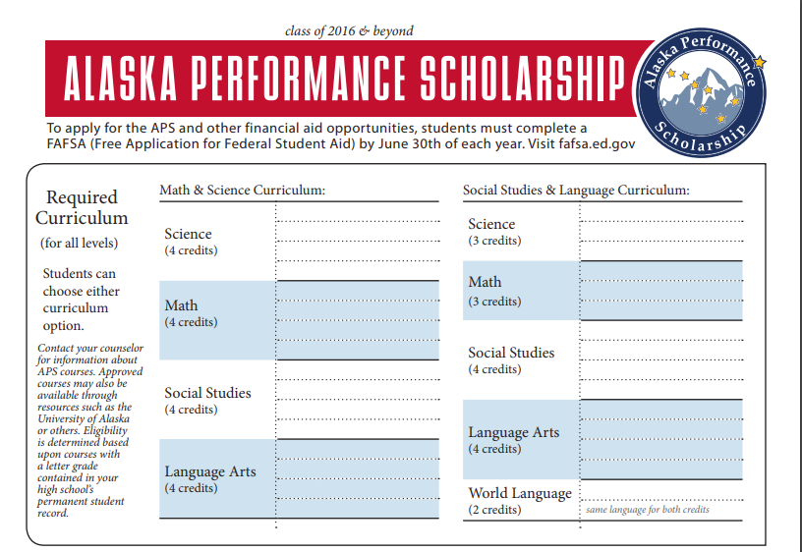

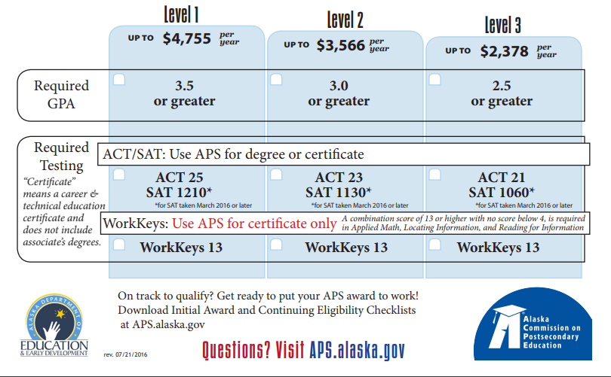
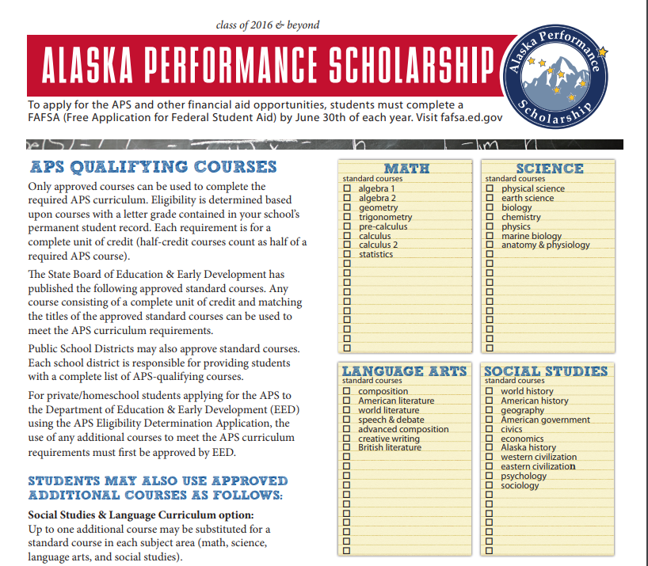
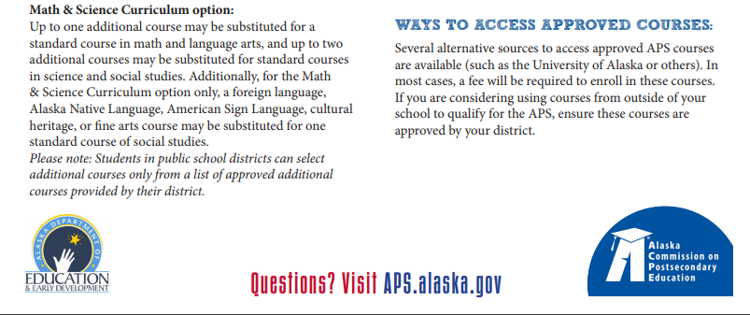
We are proud to announce that the Soldotna High School Counseling Program is an American School Counselor Association Recognized ASCA Model Program. RAMP schools have implemented a school counseling program that is comprehensive, data-driven and focused on achievement & attendance.
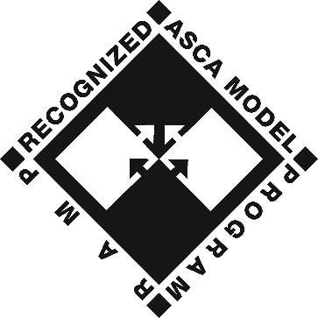
Counseling Department Events, Workshops, and Parent Nights

Specific dates posted each year on Counselor’s Corner on SOHI’s website http://soldotnahighschool.blogs.kpbsd.k12.ak.us/

September: Post-Secondary Planning (application process and college information)
September: Financial Aid Night
September: College Athletics Information Meeting (NCAA/NAIA/NJCAA) Open to all students & parents
October: Counseling Department administers the PSAT on the national date
October: FAFSA Completion Workshop #1
October: College Fair at Soldotna or Kenai High School Gym
October: Field trip visit to UAA, APU, ACC, & Charter College (6am-8pm)
November: College Application Month (prizes, recognition, application workshop days)
November: FAFSA Completion Workshop #2
January: PSAT Interpretation and Distribution of paper results and testbook return
March: Get Real Financial Reality Fair for seniors at SOHI
April: Decision Day Celebration for seniors
April: Junior/Senior parent night
May: Post-Secondary Planning (application process and college information)
Ongoing in Counseling Office: college representative visits, military recruiters, professionals

Find more information at:

-Counselor’s Corner on SOHI’s website (forms, announcements, information)
-1Stop at www.kpbsd.k12.ak.us
-Sign up for REMIND by texting @sohi2020 @sohi 2021 or @sohi2022 or @sohi 2023 to the number 81010 (Or get the Remind app and sign up there or visit www.remind.com )
-Sign up for presentations in the Counseling Office for College/Recruiter/Career visits

Margaret Griffin, Last Names A-L, 907-260-7073, mgriffin@kpbsd.k12.ak.us
Megan Murphy, Last Names M-Z, 907-260-7059, mmurphy@kpbsd.k12.ak.us
Nelma Treider, Counseling Secretary & Registrar, 907-260-7072, ntreider@kpbsd.k12.ak.us

Soldotna High School Core Counseling Curriculum 10th-12th

10th grade

-September classroom visits – topics include PSAT, ACT/SAT, NCAA/NAIA/NJCAA, sophomore year timeline, APS, Jumpstart, Counselor’s Corner on SOHI website, Scholarship folder activity tracking, and Post-Secondary planning nights.

-October classroom lesson (one day) – AKCIS career exploration activites
PowerSchool>AKCIS>Assessments>Reality Check (saved in AKCIS portfolio)
Career exploration worksheet
Update Personal Learning and Career Plan (PLCP) in AKCIS

-March classroom lesson (one day) – Registration for Junior year
Presentation topics include credits/graduation requirements, college requirements, APS, NCAA/NAIA, transcripts and how to get one, course offerings, and enrollment instructions

-March/April/May individual appointments to discuss post-secondary plans, credits, APS, UA Scholars, PSAT, ACT/SAT, Accuplacer/ALEKS, Jumpstart, NCAA/NAIA/NJCAA, Counselor’s Corner on SOHI websit, timelines for each year, field trips, parent nights, FAFSA workshops, scholarship folder activity tracting, and course selection for Junior year.

11th grade

-September classroom visits – topics include PSAT, ACT/SAT, NCAA/NAIA/NJCAA, junior year timeline, APS, Jumpstart, Counselor’s Corner on SOHI website, Scholarship folder activity tracking, and Post-Secondary planning nights.

-October classroom lesson (one day) – AKCIS college search and resume workshop
PowerSchool>AKCIS>Education>School Sort (search for colleges, save in AKCIS portfolio)
School/Program/College comparision worksheet
Resume instruction and worksheet guide
PowerSchool>AKCIS>Employment>Resume Creator (enter info, save in AKCIS)
Update Personal Learning and Career Plan (PLCP) in AKCIS

-March classroom lesson (one day) – Registration for Senior year
Presentation topics include credits/graduation requirements, college requirements, APS, NCAA/NAIA, transcripts and how to get one, course offerings, and enrollment instructions

-March/April/May individual appointments to discuss post-secondary plans, credits, APS, UA Scholars, PSAT, ACT/SAT, Accuplacer/ALEKS, Jumpstart, NCAA/NAIA/NJCAA, Counselor’s Corner on SOHI websit, timelines for each year, field trips, parent nights, FAFSA workshops, scholarship folder activity tracting, and course selection for Senior year.

12th grade

-September classroom visits – topics include PSAT, ACT/SAT, NCAA/NAIA/NJCAA, senior year timeline, APS, Jumpstart, Counselor’s Corner on SOHI website, Scholarship folder activity tracking, and Post-Secondary planning nights.

-September classroom lesson (two days) – Scholarship Folder, Scholarship Search, and College Essay
Review of Junior year school sort, scholarship search instruction and samples
PowerSchool>AKCIS>Education>Financial Aid Sort (search and save in AKCIS portfolio)
Scholarship Folder completion
Personal Narrative instruction, samples, and writers workshop
Update Personal Learning and Career Plan (PLCP) in AKCIS

-October/November/December individual appointments to discuss post-secondary plans, credits, APS, UA Scholars, PSAT, ACT/SAT, Accuplacer/ALEKS, Jumpstart, NCAA/NAIA/NJCAA, Counselor’s Corner on SOHI websit, timelines for each year, field trips, parent nights, FAFSA workshops, scholarship folder activity tracting, and course selection for second semester of Senior year.

Please Note: Two semesters are equivalent to one year.

CREATIVE ARTS

Art
Title: GRAPHICS AA735 Length: One Semester
Prerequisite: None Fee: $20
Graphics is a creative arts class focused on understanding and implementing the formal design principles into artwork for use in advertising, photography, graphic design, game design, and more. Students will experiment with a variety of techniques and materials that may include drawing, painting, printmaking, sculpting, digital photography, and more. Students will learn to analyze their own art and the art of others and will be encouraged to relate the beauty and meaning of art to their lives. This course will stress the use of the Elements and Principles of Design, the study of artists, the improvement of creative thinking skills, and the process of making informed judgments about art. Students will be exposes to the historical and contemporary role of the arts in Alaska, the nation, and the world. Portfolio development will be required. Technology may be applied for reference or support.

Title: SCULPTURE AA730 Length: One Semester
Prerequisite: None Fee: $20
This course covers the fundamental skills, knowledge, attitudes, and technology necessary to begin to understand sculpture. Various sculptural processes are explored, and students work with a variety of materials and tools. Students learn to make critical judgments about their own art and the art of others and are encouraged to relate the beauty and meaning of art to their lives. They are exposed to the historical and contemporary role of sculpture throughout the world. Portfolio development may be required. Technology may be applied for reference or support.

Title: DRAWING AND DESIGN AA815 Length: One Semester
Prerequisite: None Fee: $20
In this course, students refine their drawing and design skills. A variety of subject matter, materials, and technologies are used on a two dimensional surface. Students will develop formal drawing, painting, and printmaking skills. Students continue to develop critiquing skills and are encouraged to relate beauty and meaning of art to their lives. They gain an understanding of values, beliefs, ideas, and traditions of various cultures through the study of drawing and design.

Title: INTERMEDIATE ART (2) AA710 Length: One Semester
Prerequisite: Students should have taken one credit of fine art classes prior Fee: $20
Intermediate Art is a progression of art techniques and theory designed for high school students. Students continue to explore a variety of techniques and materials that may include drawing, painting, printmaking, sculpture, weaving, and hand built ceramics. During project creation, students will purposefully apply multiple art elements, moving from knowledge to successful art production. Students will learn to make critical judgments about their own art and the art of others. They will be exposed to the historical and contemporary role of art from various cultures throughout the world and will be encouraged to relate the beauty and meaning of art to their lives. Students will apply a basic understanding of the Elements and Principles of Design to create successful pieces of art.

Title: ADVANCED ART (3) AA715 Length: One Semester
Prerequisite: Students should have taken intermediate art prior Fee: $20
Advanced Art is a course for students who have successfully passed Intro and Intermediate Art. Students will experiment with a variety of techniques and materials that may include drawing, painting, printmaking, sculpting, weaving, and pottery. Students will learn to analyze their own art and the art of others and will be encouraged to relate the beauty and meaning of art to their lives. This course will stress the use of the Elements and Principles of Design, the study of artists, the improvement of creative thinking skills, and the process of making informed judgments about art. Students will be exposed to the historical and
contemporary role of the Arts in Alaska, the nation, and the world. Portfolio development will be required. Technology may be applied for reference or support.

Title: BEGINNING CERAMICS AA720 Length: One Semester
Prerequisite: None Fee: $30
Beginning Ceramics covers the fundamental skills, knowledge, and techniques necessary to begin understanding ceramics. Students learn a variety of hand building techniques, including, pinch, coil and slab construction, as well as an introduction to wheel throwing. They will also study the processes unique to ceramics including the stages of clay, firing and glazing. They will be exposed to the historical and contemporary role of pottery from various cultures throughout the world and will be encouraged to relate the beauty and meaning of art to their lives. Students will acquire a basic understanding of the Elements and Principles of Design that go into a successful piece of pottery.

Title: INTERMEDIATE CERAMICS AA810 Length: One Semester
Prerequisite: Beginning Ceramics Fee: $30
Intermediate Ceramics expands upon the fundamental skills, knowledge, and techniques necessary for creating ceramics. Students practice a variety of wheel thrown and hand building techniques, including: pinch, coil and slab construction. An emphasis will be placed upon quality construction and design development. Students will also broaden their study of the processes unique to ceramics including the stages of clay, firing and glazing. The course includes the study of Artist and Cultures. They will be exposed to the historical and contemporary role of pottery from various cultures throughout the world and will be encouraged to relate the beauty and meaning of art to their lives. Students will apply a basic understanding of the Elements and Principles of Design to create successful pieces of pottery.

Title: ADVANCED CERAMICS AA725 Length: One Semester
Prerequisite: Junior standing/Intermediate Ceramics/Teacher Discretion Fee: $30
Advanced Ceramics covers the in depth skills, knowledge, and techniques necessary to creating advanced level ceramics. Students apply a variety of wheel thrown and hand building techniques. They will also study and refine the processes unique to ceramics including the stages of clay, firing and glazing. Students will continue to learn to make critical judgments about their own art and the art of others. They will be exposed to the historical and contemporary role of pottery from various cultures throughout the world and will be encouraged to relate the beauty and meaning of art to their lives. Students will utilize advanced levels of understanding of the Elements and Principles of Design and apply them to create successful pieces of pottery.

CREATIVE ARTS

Drama

Title: DRAMA 1 VV705 Length: One Semester
Prerequisite: None
This course is an introduction to basic acting skills, and studying plays as a literary form. It involves improvisation, movement, character analysis, stage terminology, mime, and scripted material.

Title: DRAMA 2 VV710 Length: One Semester
Prerequisite: Drama 1
This course involves higher levels of acting skills and more challenging scripted material.

CREATIVE ARTS

Music

Title: MIXED CHOIR UU725 Length: Two Semesters
Prerequisite: None Fee: $20/semester
Open to all students, with an emphasis on the inexperienced singer. A wide range of songs and styles will be explored, as students will learn more about their voices and music. Emphasis is on participation, although performances are required.

Title: SWING CHOIR UU715 Length: Two Semesters Fee: $20/semester
Prerequisite: Audition for Teacher/Student must be enrolled on one of the large performing groups, either Mixed Choir or Symphonic Band.
This course emphasizes advanced vocal performance with some choreography. This course requires a mature voice, great work ethic, and positive attitude. Numerous performance opportunities are available requiring outside-of-classroom commitments.

Title: SYMPHONIC BAND UU735 Length: Two Semesters
Prerequisite: Audition for Teacher Fee: $20/semester
Symphonic band is the main instrumental performing group. It is open to advanced players who perform satisfactorily for the director. Throughout the year, this group will play in concerts and at football games, and other sporting events, as well as participate in out-of-class band activities. Concerts are mandatory.

Title: JAZZ ENSEMBLE UU785 Length: Two Semesters
Prerequisite: Audition for Teacher Fee: $20
Jazz ensemble consists of a select group of instrumentalists who perform music in the jazz and jazz/rock style. Many public performances and concerts are included in the expectations of this class. This is an "early bird" class .25 credit per semester.

Title: GUITAR 1 UU740 Length: One Semester
Prerequisite: None
This course is open to all students interested in playing the guitar. Individuals as well as groups will work on learning all strings of the guitar, music fundamentals, reading notes, and chords.
Guitar 1 and 2 may only be taken one semester each. This class may be repeated for credit.

Title: GUITAR 2 UU745 Length: One Semester
Prerequisite: Guitar 1
More advanced classes will require individual work with chording, finger picking, and working with different musical styles.
Guitar 1 and 2 may only be taken one semester each. This class may be repeated for credit.
Title: Music Appreciation
Prerequisite: Going into music school post high school
Students will identify and select specific passages, sections, or movements in musical works that express personal experiences and interests, moods, visual images, etc. They will analyze how the elements of music relate to the composition’s style, function, and content, and explain the implications for rehearsal and performance.

CREATIVE ARTS/PRACTICAL ARTS
Business/ Photography

Title: YEARBOOK AA760/BB750 Length: Semester long (start S1, not S2)
Prerequisite: Must complete the interview/application process.
This course will teach students to understand, develop, and use the techniques found in the occupational field of commercial publishing. Students will assist in producing publishable documents (e.g. yearbook, brochures, etc.). This course requires good attendance and motivation to meet deadlines. It will also address academic and vocational educational standards, and may be taken for practical or creative art credit. Course may be repeated for credit.

Title: DIGITAL PHOTOGRAPHY 1 AA795 / BB865 Length: One Semester
Prerequisite: None Fee: None
This is an introductory digital photo course. Use of digital cameras, settings and functions, media types, file types, and file organization will be covered. Graphic editing software will be used to manipulate photos. Photocomposition, presentation, and lighting will be covered. Employment opportunities, including photojournalism and graphic photo artists, will also be investigated. The course will integrate academic and vocational education standards.
This course may be taken for practical or creative art credit. ** Due to the limited number of cameras the school has available for student use, students should bring their own digital cameras to class daily.

Title: DIGITAL PHOTOGRAPHY 2 AA800 / BB870 Length: One Semester
Prerequisite: Successful completion of Digital Photography 1 Fee: None
This course requires increasingly complex photography and digital editing assignments. Presentation and printing techniques will be refined. Portfolios will be developed. Advanced camera settings and functions will be used.
**Photo 2 students must have their own camera. This course may be taken for practical or creative art credit.

PRACTICAL ARTS

Business

Title: INTRO TO COMPUTER PROGRAMMING I BB730 Length: One Semester
Prerequisite: None Fee: None
  - Topics covered
    - Digital Information /What is a Computer?
    - Intro to JavaScript, Drawing & Animation
    - Intro to HTML/CSS
    - Google Sites Web Design
  - Description:
    - Get started with some basic computer programming, web design, and other technology! At the beginning, look through the guts of what makes your technology work and learn how all of the pieces interact, then start making them do your bidding with project-based programming in HTML, CSS, JavaScript. Learn how to put together websites and blogs, and learn skills that you can easily turn into business or fun pastimes later on.

Title: INTRO TO COMPUTER PROGRAMMING II BB735 Length: One Semester
Prerequisite: Intro to Computer Programming I Fee: None
  - Topics Covered
    - Python Language
    - IT Essentials
Intro to Computer Programming continued:
    - Intro to A+ Certification
    - Networking Basics
    - Intro to Linux
      - Raspberry Pi Lab
  - Description
    - Extend what you learned in Intro to Computer Programming I (required). Begin working on industry certification, including tech industry standards like the A+ (computer hardware and configuration). Learn how networks interact, begin with the easy-to-learn Python programming language, and learn how to build a web server (optionally on a Raspberry Pi minicomputer!).

Title: TECH PATHWAYS A BB740 Length: One Semester
Prerequisite: Intro to Computer Programming I & II Fee: None
  - Topics Covered
    - Mobile App Development
      - Android
      - IOS
      - Java
      - C++/Swift
    - Web Development
    - Intro to Internet Tech & Principles
  - Description
    - After taking both of the Intro courses, you now have the option of taking this class or Pathways B (or both!), which expand on skills that you learned. Pathways A focuses on mobile app development (programming Android apps in Java), and web development, which will sharpen your knowledge of servers, websites, web applications, and the intricacies of databases.

Title: TECH PATHWAYS B BB745 Length: One Semester
Prerequisite: Intro to Computer Programming I & II Fee: None
  - Topics Covered
    - Hardware & CISCO Certification
      - AP Test Available
    - A+ Certification
    - Operating Systems
  - Description
    - After taking both of the Intro courses, you now have the option of taking this class or Pathways A (or both!), which expand on skills that you learned. Pathways B focuses on hardware and networking certifications through CISCO. Additionally, you can take an AP test during this course for AP and college credit. You will also be eligible to take an A+ Certification test and will study the intricacies of troubleshooting and handling advanced operating system functions.

PRACTICAL ARTS
Family and Consumer Science

Title: NUTRITION OF FOODS HH800 Length: One Semester
Fee: $30
This course is designed to provide firsthand experiences stressing nutritional science and the relationship with food. Students apply nutrition and wellness concepts in food labs. Topics include food choices, kitchen safety, careers, food preparation, and nutrition.

Title: CULINARY ARTS HH730 Length: One Semester
Prerequisite: Nutrition of Foods Fee: $30
This course builds upon the basic skills learned in Nutrition. Students will investigate careers in the food service industry, kitchen safety, food preparation and a variety of individual units of food. A strong emphasis is on culinary careers and workplace skills.

Title: RELATIONSHIPS HH810 Length: One Semester
Prerequisite: Sophomore Fee: none
In this course, emphasis is placed on the individual and his or her relationships with others. Basic human development and behavioral characteristics of individuals form the basic needs, development of psychological and physiological needs.

Students will examine basic needs, development of interpersonal skills, behavior modification, and use of assertiveness, elimination of stereotyping, dealing with stress, conflict, and abuse, and practicing problem-solving techniques. Personal relationships allow the students to obtain self-knowledge and to practice the skills necessary for a successful and responsible life. The emphasis is for each person to grow and achieve his or her full potential, by developing their future employability skills. Preliminary career investigation relative to personal characteristics, wants, and goals is appropriate in this course.

PRACTICAL ARTS
Career & Technical Education

Title: CAD/CAM 1 and 2 II950/II951 Length: One Semester
Fee: $30
This course introduces the theory and application of computer programs that provide the automatic generation of CNC machine tool codes from the entry of part geometry. Operator designs and runs tool path for CNC machines in 2-1/2D. This technology eliminates the need for the CNC programmer to master the traditional M and G codes and dramatically shortens CNC programming time.
- Introduction to basic drafting and machining tools and techniques * Measurement and scales
- Views and planes * Dimension techniques * Pictorial view
- Careers in drafting and machining * Understanding a 2D model

PRACTICAL ARTS
Career & Technical Education
INDUSTRIAL TECHNOLOGY CAREER PATHWAY

Title: VIDEOGRAPHY II860 Length: One Semester
Prerequisite: None Fee: $20
This course is designed to educate students in the operation, maintenance, and production of video communications,
as well as, video camera operation and video editing. The students will apply their skills by videotaping, editing,
rendering and producing DVD’s of events that take place throughout the year. Examples of past productions have
been the following: Christmas Choir concerts, School Plays, Promenade, Video Yearbooks, Graduation ceremony highlight videos.

Title: AERIAL VIDEOGRAPHY II895 Length: One Semester
Prerequisite: Videography or instructor approval. Fee: $20
Develop knowledge and understanding of FAA regulations, airspace, map orienteering, physics of flight,
flight safety and basics, basic flight maneuvers both GPS assisted and non-GPS assisted, advanced
drone (UAS) flight maneuvers, basic drone construction, wiring, and programming. Earn certification in DJI Phantom series.
In addition, Inspire series and complete preparation for commercial licensing through the FAA Part 107 UAS commercial
licensing regulations.

Title: WELDING 1 II775 Length: One Semester
Prerequisite: Sophomore Standing Fee: $40 + project fees
Welding 1 will give the student a beginning level of exposure to oxy-acetylene welding and cutting operations, grinding operations and arc welding. At the end of this course, students will be able to perform 1G and 2G operations using 6011. Safe equipment use and processes will be covered.

Title: WELDING 2 II780 Length: One Semester
Prerequisite: Welding1/Sophomore Standing Fee: $40 + project fees
Welding 2 is designed to give students an in depth study in advanced arc welding processes. Metallurgy properties and gas shielded welding techniques will be taught. At the end of this course, students will be able to
perform 1G, 2G, 3G, 4G, 1F, 2F, 3F and 4F operations using deep-penetration and low-hydrogen based rod. Safe equipment use and processes will be covered.

Title: WELDING 3 II960 Length: One Semester
Prerequisite: Welding2/Sophomore Standing Fee: $40 + project fees
Welding 3 will give the student a beginning level of exposure to aluminum welding operations and introduction to project fabrication. Students will mentor and supervise the demonstration of inexperienced/beginning
Welding students. The NCCER “Basic Safety” Core will be taught in this class. Safe equipment use and processes will be covered.

Title: WELDING 4 II965 Length: One Semester
Prerequisite: Welding3/Sophomore Standing Fee: $40 + project fees
Welding 4 will give the student an advanced level of exposure to steel and aluminum welding operations through project fabrication. Students will learn to mentor and supervise the demonstration of inexperienced/beginning welding students. Safe equipment use and processes will be covered.

2 hr. block WFDC
Title: INTRODUCTION TO AUTOMOTIVE TECHNOLOGY II970 Length: One Semester
Introduction to Auto introduces the student to the responsibilities of automobile ownership and is an introduction to automotive repair technology. Maintenance, legal issues, and owner repairs are included in this course as well as introducing the automotive repair field to youth interested in pursuing a career as an automotive technician. Labs include all phases of preventive and scheduled maintenance for both industry and personal use. Topics covered include: personal safety in the auto lab, auto chemical safety, hand tool identification and safe use, power tool and equipment identification and safe use, basic automotive systems, driveway and professional repairs, emergency repairs and procedures, standard repair procedures,
This course is a two-hour block held at the Workforce Development Center in Kenai.

Title: AUTOMOTIVE SERVICE TECH 1 II971 Length: One Semester
Prerequisite: Introduction to Automotive Technology Fee: $35
This course is an extension of Intro to Automotive and is designed to provide students with higher-level understanding of engine function and shop practices and procedures. Vehicle maintenance is emphasized.
This course is a two-hour block held at the Workforce Development Center in Kenai.

Title: CONSTRUCTION 1 II725 Length: One Semester
Prerequisite: None Fee: Project Fees
This course is a beginning level construction class designed to teach students the basic information and techniques that apply to the building trades industry. Safe equipment use and processes will be covered. Tools can be hazardous if used improperly; self-discipline is necessary. A safety test must be passed before hazardous tools or materials may be used.

Title: CONSTRUCTION 2 II730 Length: One Semester
Prerequisite: Construction 1 Fee: Project Fees
Construction 2 is a semester course designed to provide students the opportunity to build on the skills learned in Construction 1, while at the same time learning advanced construction techniques and processes. NCCER Modules will be covered in this class.

Title: CONSTRUCTION 3 II735 Length: One Semester
Prerequisite: Construction 2/Sophomore standing Fee: Project Fees
This course is an advanced level construction class designed to build on skills learned in the previous Construction classes. NCCER Modules will be covered in this class.

Title: CONSTRUCTION 4 II955 Length: One Semester
Prerequisite: Construction 3/Sophomore standing Fee: Project Fees
This course is an advanced level construction class designed to build on skills learned in the previous Construction classes and to develop leadership and management skills that apply to the building trades industry. NCCER Modules will be covered in this class.

Title: MARINE TECHNOLOGY WW735 Length: One Semester
Prerequisite: None Fee: $20
This course is designed to provide students with an understanding of maritime occupations. The course includes experiences and exposure to the following areas: Basic boat construction, principles of boat handling and nomenclature, safety and legal
requirements, principles of cold-water survival, principles of navigation, navigational rules, aids to navigation, piloting, marlin spiking, seamanship, weather, fish identification, seafood processing and commercial fishing technology.

PRACTICAL ART

ENGINEERING
2 hr. block at WFDC
Title: PRINCIPLES OF ENGINEERING II925/SS 870 Length: One Semester
Prerequisite: Algebra I – passed with C or better. Principles of Engineering classes may count as practical art OR science credit
Principles of Engineering (POE), is the second in a series of classes that offers students in-depth, hands-on knowledge of engineering and technology-based careers and the design processes they use. Students will have the opportunity to explore and solve real-world problems using Fischertechnik building kits, computer software, and a tensile stress analyzer. POE also addresses the social and political consequences of technology. Grading is project based, with an emphasis on problem solving and communicating results using various reports formats.

Title: Digital Electronics II945 2 hr. block at WFDC
Length: 2nd semester
Digital Electronics is a course in applied logic that encompasses the application of electronic circuits and devices. Computer simulation and coding software is used to design and test digital circuitry prior to the actual construction of circuits and devices. This course is part of the PLTW (Project Lead the Way) Pre-Engineering Program. Can count as practical art OR science credit.

WORLD LANGUAGE
Title: SPANISH 1 WL765 Length: Two Semesters
Prerequisite: None
Spanish I introduces students to the language and culture of Spanish speaking countries in Central America, South America, and Spain. In this course, students will learn to read, write, speak, and listen in Spanish. They will also have the opportunity to participate in customs from numerous regions and broaden their cultural understanding and world perspective. It is suggested that students enrolling in this course have received a passing grade in the previous year’s Language Arts class.

Title: SPANISH 2 WL770 Length: Two Semesters
Prerequisite: Spanish 1 w/grade of C or better
Spanish II is an intermediate level course. In this class, students will expand on their ability to read, write, speak, and listen in Spanish. During this course, they will learn the two forms of the past tense in Spanish and continue to develop their vocabulary. Students will also continue to broaden their worldview and cultural understanding by participating in a number of cultural activities from Central America, South America, and Spain.

Title: SPANISH 3 (Advanced Spanish) WL775 Length: Two Semesters
Prerequisite: Spanish 2 w/grade of C or better
Spanish 3 is an advanced intermediate level course. In this class, students will expand on their ability to read, write, speak, and listen in Spanish. During this course, students will learn additional verb tenses including the future and conditional tenses and continue to develop their vocabulary. Students will also continue to broaden their worldview and cultural understanding by participating in a number of cultural activities from Central America, South America, and Spain. This course is focused on content and language usage.

ENGLISH

Title: LANGUAGE ARTS 10 LL710 Length: Two Semesters
Prerequisite: Language Arts 9
Poetry, drama, mythology, short stories, novels, and nonfiction forms will be studied from a wide range of world authors. Composition will include a review of 7-9 grade grammar and composition skills, spelling and grammar at the 10th grade level, and the development of paragraphs and the multi-paragraph form, including correct MLA formatting and citation.

Title: LANGUAGE ARTS – HONORS 10 LL711 Length: Two Semesters
Prerequisite: Based on writing assessments, standardized test scores, and grades. Previous honors enrollment is recommended but not required. Students without prior high school Honors English experience are encouraged to consult with previous English teachers and the sophomore honors teacher regarding expectations. Honors English 10 is for students who have demonstrated continued proficiency and an appreciation for literature and writing. New modes of research, technology, and communications prepare students for the academic demands of research and analytical reading and writing. Special projects tailored to individual interests and needs coupled with a rigorous reading and writing program enable students to investigate language to enrich comprehension and to develop self-expression.
Students are expected to begin applying analytical concepts of a more challenging curriculum of fiction, nonfiction, poetry, and drama. Essays will focus on broad and supported interpretations of texts and demonstrate a clear understanding of advanced vocabulary and grammatical structures, as well as proper MLA formatting and citation. Students are expected to be able to read and write on an independent basis.
Extensive reading outside of class is required. This course provides the academic background necessary for entering into Honors 11 and Advanced Placement English.

Title: LANGUAGE ARTS 11 LL715 Length: Two Semesters
Prerequisite: Language Arts 10
Language Arts 11 will provide an analysis of a wide range of American Literature, from the native oral tradition to modernism texts. Composition will provide a review of 7-10 grade composition and grammar skills. This course will include spelling, grammar, and usage at the 11th grade level, as well as proper MLA formatting and citation.

Title: LANGUAGE ARTS – HONORS 11 LL716 Length: Two Semesters
Prerequisite: Based on writing assessments, standardized test scores, and grades. Previous honors enrollment is recommended but not required. Students without prior high school honors English experience are encouraged to consult with previous English teachers and the junior honors teacher regarding expectations.
Honors English 11 is designed for students to further develop and refine their reading, writing, and critical thinking skills through an intensive study of selected American literature and appropriate oral and written responses. Students are required to read a minimum of five supplemental novels from which informed class discussions, analytical essays, and projects are derived.
Students are expected to read vigorously and critically, and to read about the literature they have been assigned, paying particular attention to elements of style, interpretation, structure, syntax, and meaning. During the second semester, students are required to write an extensively researched and documented research paper, including correct MLA formatting and citation. While a review of grammar, mechanics, vocabulary and usage may be provided as needed, students are expected to demonstrate higher than average abilities in these areas. In preparation for Advanced Placement English, the curriculum will reinforce the development of complex thought processes, independence in learning, and clarity of expression. Required outside reading is both a reinforcement and extension of classroom instruction.

Title: LANGUAGE ARTS 12 LL790 Length: Two Semesters
Prerequisite: Language Arts 11
This full-year course focuses on British literature. It will examine significant literary movements, from Anglo-Saxon poetry to post-modernism. There will be an emphasis upon writing analysis based essays, rhetoric, grammar and vocabulary at the 12th grade level, as well as proper MLA formatting and citation.

Title: ADVANCED PLACEMENT ENGLISH LL760 Length: Two Semesters
Prerequisite: Students must have completed 11th Honors LA in order to enroll in this class. Students who did not take 11th Honors may be permitted to take the class only with instructor approval. Students are encouraged to consult with previous English teachers and the AP English teacher regarding expectations.
AP English is a senior-level course designed to engage college-bound seniors in the careful reading and critical analysis of classic and contemporary British, American, and European literature. Through the active reading of a rigorous selection of texts, students will deepen their understanding of the ways writers use language to provide both meaning and pleasure for their readers. Writing assignments focus on the critical analysis of literature, including expository, analytical, and argumentative essays. Toward that end, writing instruction focuses on developing coherence, unity, precision, structure, and stylistic maturity. Additionally, students prepare and practice for the Advanced Placement English Exam. It is expected that by the end of this course, students will be able to employ a variety of test-taking skills and techniques that will enable them to satisfactorily complete both the multiple-choice and essay portions of the exam. AP is a college-level course. Depending on individual institutional policies, students who successfully complete the Advanced Placement Exam may earn college credit.
** Having met or exceeded the expectations for Advanced Placement coursework by colleges and universities, this course is authorized by The College Board to use the AP® designation.

Title: Creative Writing-Poetry LL750A Length: One Semester
Prerequisite: Open only to 11 and 12 graders.
The course will examine ways that the craft of creative writing shapes the world and allows students to practice reflection and self-expression through poetry and other possible forms. This course, based on a writer’s workshop model, is designed to get students working together to perfect their pieces and get them published. Students will critically read and analyze select exemplar texts and create their own works by following the writing process. By the end of the semester, students will have portfolios. Because the course does include critical reading, writing and speaking, any student in grades 11 and 12 should get a full English language arts credit for taking it. This course is not open to ninth or tenth grade students.

Title: Creative Writing-Prose LL750B Length: One Semester
Prerequisite: Open only to 11th and 12th graders
This course will examine ways that the craft of creative writing shapes the world and allows students to practice reflection and self-expression. Students study the forms of creative non-fiction and fiction. This course, based on a writer’s workshop model, is designed to get students working together to perfect their pieces and get them published. Students will critically read and analyze select exemplar texts and create their own works by following the writing process. By the end of the semester, students will have portfolios. Because the course does include critical reading, writing, and speaking, and student in grades 11 or 12 should get a full English language arts credit for taking it. This course is not open to ninth or tenth grade students.

Title: Drama Analysis LL855 Length: One year
Prerequisite: Open only to 11th or 12th graders
This course expands student understanding of how the histories of comedy and tragedy represent human modes of expression over time, and how genres are reshaped and adapted as culture changes. The course will focus on literary analysis, analytical writing and discussion. Students study the foundations and growth of comic and tragic theatre tradition through its conventions, techniques, and themes to understand the role of comedy and tragedy in society. Because the course does include critical reading, writing, and speaking, any student in grades 11 or 12 should get a full English language arts credit for taking it. This course is not open to ninth or tenth grade students.

Title: Film as Literature
Prerequisite: Open only to 11th or 12th graders LL735 Length: One year
This course expands analysis, reasoning, and writing skills using film as a basis for study. Students learn the origin and background of film, as well as the stylistic implications behind new technological elements developed. Students then examine different film movement and the unique ways in which style creates meaning for audiences. Students will understand the elements of film analysis and criticism, and their role in evaluating the narrative, artistic, symbolic, cultural and entertainment value of film. Because the course does include critical reading, writing, and speaking, any student in grades 11 or 12 should get a full English language arts credit for taking it. This course is not open to ninth 10th grade students.

Title: Journalism
Prerequisite: Open only to 11th or 12th graders LL740 Length: One semester
The course will focus on journalism in modern society, with regards to the types of journalism, the process, and the business itself. Students will examine forms ranging from basic reporting to photojournalism, and creating individual portfolios and a teen-oriented newspaper to distribute to the school. Because the course does include critical reading, writing, and speaking, any student in grades 11 or 12 should get a ½ English language arts credit for taking it. This course is not open to 9th or 10th graders.

MATHEMATICS

Title: ALGEBRA READINESS MM706 Length: Two Semesters
(Algebra A and Algebra B equal a two-year Algebra sequence)
Prerequisite: Teacher Recommendation
This course focuses on mastery of computational skills and teaches the fundamentals necessary for algebra.

Title: ALGEBRA MM725 Length: Two Semesters
Prerequisite: Pass Algebra Readiness (Pre-Algebra) or Teacher Recommendation
This course uses real-life situations to teach algebraic issues including the addition, multiplication, and factoring of algebraic expressions; solving and graphing linear and quadratic equations; systems of equations; introduction to matrices, probability, and radical and logarithmic functions. A scientific calculator is required.

Title: GEOMETRY MM730 Length: Two Semesters
Prerequisite: Algebra
This course integrates coordinate and transformational approaches with real-world applications while developing deductive proof. Two-dimensional geometry focuses on similarity and congruence, perimeter and area, circles, and scatter and linear graphs. Uses algebraic skills such as linear and quadratic equation solving, factoring, and graphing. Explores solid geometry topics including nets, surface area, and volume. A scientific calculator is required.

Title: ADVANCED ALGEBRA MM735 Length: Two Semesters
Prerequisite: Geometry
This course uses real-world applications to teach algebraic expressions, solving, linear and quadratic equation functions, powers, roots, logarithms, and polynomial and trigonometric functions. Rational expressions, scatterplots, and linear programming are also covered. A graphing calculator is required, preferably a TI-83.

Title: PRE-CALCULUS AND TRIGONOMETRY MM740 Length: Two Semesters
Prerequisite: Advanced Algebra
Explores function families: polynomial, trigonometric, circular, and logarithmic. This course also covers conic sections, polar coordinates, complex numbers, and series. A graphing calculator is required.

Title: ADVANCED PLACEMENT CALCULUS MM755 Length: Two Semesters
Prerequisite: Pre-Calculus and Trigonometry
Calculus is a study of four main topics: limits, derivatives, definite integral, and indefinite integral. Students will know the definitions, understand the concepts, be able to do the operations, and then apply them to real world problems. AP is a college-level course. Depending on individual institutional policies, students who successfully complete the AP exam may earn college credit. When students take this course, it is assumed that they will take the AP test at the end of the year. A graphing calculator is required, preferably one with a symbolic manipulator such as the TI-89 or equivalent.
** Having met or exceeded the expectations for Advanced Placement coursework by colleges and universities, this course is authorized by The College Board to use the AP® designation.

Title: PERSONAL FINANCE MM726 Length: One Semester
Prerequisite: Junior/Senior Standing 1st Semester
This course places an emphasis on personal finance, which includes math-related topics such as budgeting income, income tax, loans, investments, credit cards, saving, cash purchasing and others.
Title: BUSINESS MATH MM727 Length: One Semester
Prerequisite: Junior/Senior Standing 2nd Semester
This course places an emphasis on application of mathematical concept in the business world. Topics include: small business, taxes, payroll, investing, capital, loss, assets, liabilities, basic accounting, licensing, government agencies and others.

PHYSICAL EDUCATION

Title: INDIVIDUAL/TEAM ACTIVITIES PP710 Length: One Semester

INDIVIDUAL/TEAM ACTIVITIES PP710 Length: One Semester

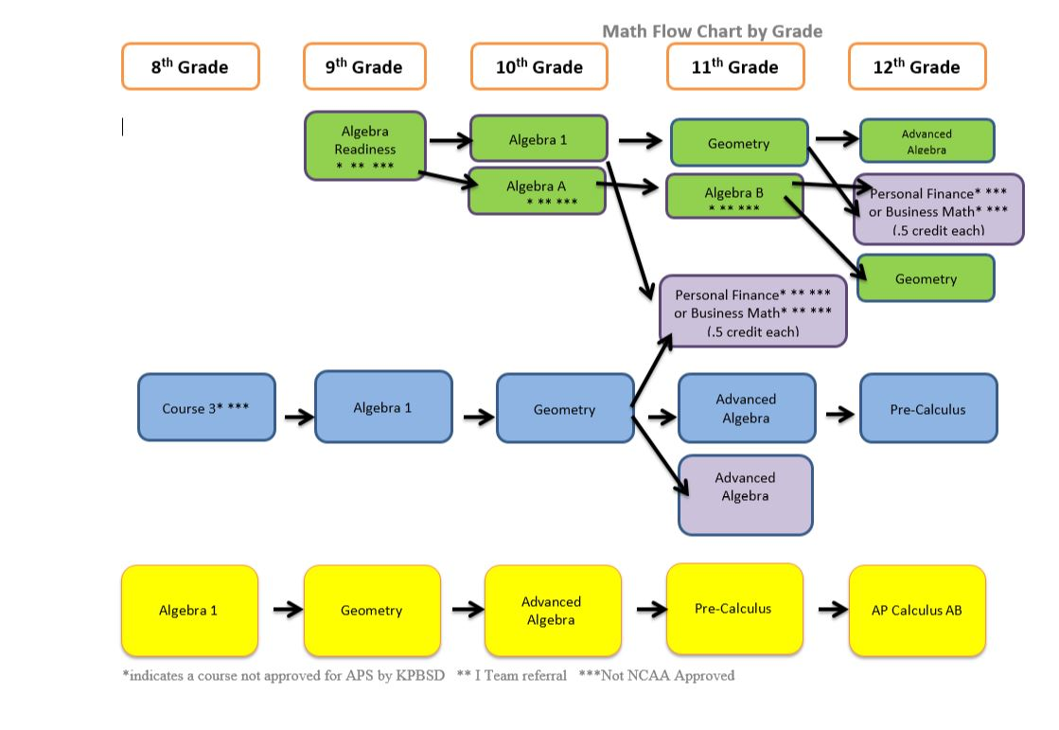
PHYSICAL EDUCATION

Title: TEAM ACTIVITIES PP710 Length: One Semester
Prerequisite: None
This course is designed to offer students a variety of activities in physical education. These activities may include golf, pickle ball, volleyball, cross-country skiing, soccer, badminton, team handball, lacrosse, outdoor jogging, broomball, softball, basketball, tennis, horseshoes, and aerobic conditioning. Fee may be charged for some out-of-school activities.

Title: MOVEMENT & ACTIVITIES PP720 Length: One Semester
Prerequisite: None
This course is designed to offer a variety of physical activities for students who desire to increase strength, agility and endurance. This course encourages lifetime personal fitness through dance, movement and/or aerobic activities.

Title: PHYSICAL TRAINING PP715 Length: One Semester
Prerequisite: None Fee: $10
The goals of Speed Strength Training (Physical Training) will be to improve flexibility, speed, agility, jump ability, lifting technique, strength, power, stability and core strength. These areas must be improved through training to improve performance, reduce injury potential and optimize athletic ability. Quarterly fitness tests will be given to test physical and athletic improvements.

SCIENCE
Life Science

Title: ADVANCED PLACEMENT BIOLOGY SS735 Length: Two Semesters
Prerequisite: Biology 1 with a "B" or better/Chemistry Recommended. Junior or senior standing. Fee: $10.00
The Advanced Placement Biology course is designed to be the equivalent of a college-level introductory
Biology course, usually taken by biology majors during the first college year. It is also recommended that students successfully complete one year of high school Chemistry or Human Anatomy prior to enrolling in this course. AP is a college-level course. Depending on individual institutional policies, students who successfully complete the AP exam may earn college credit** Having met or exceeded the expectations for Advanced Placement coursework by colleges and universities, this course is authorized by The College Board to use the AP® designation.

Title: ANATOMY & PHYSIOLOGY SS725 Length: Two Semesters
Prerequisite: Completion of Biology 1 with a grade of B or better or teacher recommendation Fee: $10.00

This course is designed to provide students the opportunities to investigate all systems of the human body. In-depth study will take place through lab activities including fetal pig dissections and various tests (reflex, eye exams, and heart and respiration rates) on the students’ bodies. Learning experiences will include lecture, group projects, and independent research including term papers & brain, eye & heart dissections.

Title: MARINE BIOLOGY SS730 Length: Two Semesters
Prerequisite: Biology 1/Sophomore standing Fee: $10.00
Marine Biology is designed to provide students with opportunities to investigate the physical and biological aspects of the marine and aquatic environments. Emphasis will be placed on physical dynamics such as currents, tides, and salinity, along with how they affect the animal and plant life as well as the dynamics and interrelationship of the ecosystems.

SCIENCE

Physical Science

Title: CHEMISTRY SS775 Length: Two Semesters
Prerequisite: Advanced Algebra (previously or concurrently) Fee: $10.00
Chemistry is presented as a hands-on, laboratory-based course. The topics covered are designed to prepare students for basic college chemistry. Coursework is integrated with other academic disciplines.

Title: ADVANCED PLACEMENT CHEMISTRY SS776 Length: Two Semesters
Prerequisite: Chemistry with a "B" or better, enrollment or Fee: $10.00
completion of Pre-Calculus/Trigonometry and junior or senior standing.
The Advanced Placement Chemistry course is designed to be the equivalent of a college-level introductory Chemistry course. Science majors usually take this course during their first college year. Depending on individual institutional policies, students who successfully complete the AP exam may earn college credit. ** Having met or exceeded the expectations for Advanced Placement coursework by colleges and universities, this course is authorized by The College Board to use the AP® designation. Depending on student requests, will be offered every other year.

Title: EARTH SCIENCE SS750 Length: Two Semesters
Prerequisite: Physical Science Fee: $10.0
This course covers the study of geologic time and is designed to provide students opportunities to investigate the structure and composition of the earth and how it changes over time. In-depth study through lab activities, group projects, and independent research will concentrate in topics of special interest to Alaskans: volcanoes, earthquakes, and oil-related topics (minerals and rocks). Astronomy basics will also be covered.

Title: PHYSICAL SCIENCE SS755 Length: Two Semesters
Prerequisite: None Fee: $10.00
This course is divided into major areas: chemistry, electricity, energy, force and motion, and technology. Students will explore the scientific principles and application of technology through investigations. This course is a preparation for Earth Science, Chemistry and Physics courses.

Title: PHYSICS SS780 Length: Two Semesters
Prerequisite: Advanced Algebra (previously or concurrently) Fee: $10.00
An introduction to physics, involving motion, energy, gravity, waves and relativity. This course is designed as advanced science for students who are interested in the sciences or would like a head start for further college science courses. Physics will involve mathematical applications, with the primary focus being conceptual understanding.

Title: PRINCIPLES OF ENGINEERING II925/SS870 Length: One Semester
Prerequisite: Algebra I – passed with C or better,
Principles of Engineering (POE), is the second in a series of classes that offers students in-depth, hands-on knowledge of engineering and technology-based careers and the design processes they use. Students will have the opportunity to explore and solve real-world problems using Fischertechnik building kits, computer software, and a tensile stress analyzer. POE also addresses the social and political consequences of technology. Grading is project based, with an emphasis on problem solving and communicating results using various reports formats. *Principles of Engineering classes may count as practical art OR science credit. This course is a two-hour block held at the Workforce Development Center in Kenai.

SOCIAL STUDIES
Title: WORLD HISTORY TT705 Length: Two Semesters
Prerequisite: Sophomore standing
This tenth-grade program focuses on the history of the major cultures and societies of the world. Historical perspective is provided on major world events, movements, and conditions. This course enables the student to understand the world through exploration of the histories and cultures of past and present societies. Emphasis is on the acquisition and application of social studies skills within the context of world history. Students will apply concepts and knowledge from social studies disciplines such as geography, government, and economics, in addition to other disciplines such as world literature and science. Current events will help students see the link between past and present. Supplies: A box of colored pencils and a ruler.

Title: ADVANCED PLACEMENT WORLD HISTORY TT706 Length: Two Semesters
Prerequisite: Sophomore standing/passed Alaska History & Geography or have a cumulative 3.0 GPA. Must be enrolled in or have taken an Honor’s English class.
This course explores key themes of world history, including interaction between humans and the environment, development and interaction of cultures, state building and expansion, and conflict, creation, expansion and interaction of economic systems, development and transformation of social structures from approximately 8000 B.C.E. to the present. AP is a college-level course. Depending on individual institutional policies, students who successfully complete the AP exam may earn college credit. Units are established by the Advanced Placement system. ** Having met or exceeded the expectations for Advanced Placement coursework by colleges and universities, this course is authorized by The College Board to use the AP® designation.

Title: U.S. HISTORY TT710 Length: Two Semesters
Prerequisite: Junior standing
The eleventh-grade program is a comprehensive, integrated course in United States history from the Civil-War Era to the present. This course is organized chronologically but may be taught thematically, and is intended to serve as a capstone for U.S. History studies in the elementary and secondary schools. In-depth, student-centered exploration of issues relevant to historical inquiry and methodology will be emphasized. Integration with the 11th grade language arts curriculum through American literature will emphasize reading, writing, listening, speaking, research, critical thinking, and technical skills within a historical context.

Title: ADVANCED PLACEMENT U.S. HISTORY TT715 Length: Two Semesters
Prerequisite: Junior standing or have a cumulative 3.0 GPA. Must be enrolled in or have taken an Honor’s or AP English class. Advanced Placement U.S. History is a College Board Advanced Placement Course, which offers the student an opportunity to study American History, from the settlement of the United States to the present. AP is a college-level course. Depending on individual institutional policies, students who successfully complete the AP exam may earn college credit.
Units are established by the Advanced Placement system.
** Having met or exceeded the expectations for Advanced Placement coursework by colleges and universities, this course is authorized by The College Board to use the AP® designation.

Title: GOVERNMENT TT720 Length: One Semester
Prerequisite: Senior standing
The twelfth-grade social studies program focuses on the American political system and preparation of students for effective and productive citizenship. Government provides an in-depth, content-specific study of the Constitution, comparative political and economic systems, federal, state and local governments, International relations, and rights and responsibilities of the individual. The American legal system, legislative processes, and the Bill of Rights will be critically examined in order to invite student activism and involvement in democracy. Exposure and participation to real life experiences is a major focus in this course. Identification of issues crucial to the maintenance of democratic institutions is emphasized with a view toward resolution.

Title: ADVANCED PLACEMENT GOVERNMENT TT725 Length: One Semester
Prerequisite: Senior standing and have a cumulative 3.0 GPA. Must be enrolled in or have taken an Honor’s or AP English class.
Advanced Placement Government is a college-level course, which offers the student an opportunity to participate in an in-depth study of the American political system: its framework, traditions, values, and the rights and responsibilities of the citizens of the United States. AP is a college-level course. Depending on individual institutional policies, students who successfully complete the AP exam may earn college credit.
** Having met or exceeded the expectations for Advanced Placement coursework by colleges and universities, this course is authorized by The College Board to use the AP® designation.

Title: PSYCHOLOGY (ELECTIVE CREDIT ONLY) TT758 Length: One Semester
Prerequisite: Sophomore standing
Psyche – the mind, soul, or spirit; logos – the study of. This class is an introduction to the study of the behavior and thinking of organisms. We will examine the history of psychology and theories of differing psychologists over time. The class curriculum will include most of the following: the study of sensation and perception, motivation and emotion, stress and health, principles of learning, psychological testing, theories of personality, and psychological disorders. Each quarter students will either conduct experiments or choose a topic for a more in depth study. This course can be used to count towards APS for Social Studies.
Title: SOCIOLOGY (ELECTIVE CREDIT ONLY) TT765 Length: One Semester
Prerequisite: Sophomore standing
Sociology is an elective course that studies human society and social behavior.
The way that we view the world comes from what we learn in our everyday activities. This course deals with the social atmosphere that helps to make us who we are and how we behave. Sociology will cover topics such as culture, violence, deviance, social control, socialization and personality, group behavior, social class and social institutions. The key component of this course is the study of ourselves and the society that influences our behavior. This course can be used to count towards APS for Social Studies.

VIDEO CONFERENCING
The below semester long classes are listed in sequential order with
Polycom Certification Practicum (Level 3) scheduled to be taken 1st semester of the following year.

Title: WORLD RELATIONS Level 1/Semester 1@SoPrep TT780 Length: One Semester
Prerequisite: None *Social Studies credit
It is a one semester ½ credit Social Studies elective open to all students with the drive to become citizens of the world. World Relations/VTC is a prerequisite for Global Nomads/VTC and the VTC Certification Practicum courses. While traditional social studies courses would offer videos or textual content delivery this survey level class will focus on formal instruction. Over the course of the semester students, will video conference to connect with peers and educators from places such as Ghana, Malaysia, Palestine, Afghanistan, Australia, Canada and various US states. Topics covered range from social and political issues to cultural enrichment. The course will include a culminating assignment that is a student driven collaborative project using video conferencing technologies and other web based platforms to highlight the political, social, cultural and economic dynamics at play in the world today.

Title: GLOBAL NOMADS Level 2/Semester 2@SoPrep TT785 Length: One Semester
Prerequisite: WORLD RELATIONS THROUGH VIDEO CONFERENCING (Level 1) *Social Studies credit
Working with Polycom & Global Nomads/VTC continues the emphasis on building relationships around the world. While World Relations/VTC was a broad survey of cultures, Global Nomads/VTC emphasizes a more focused partnership with one or two cultures from the MENA (Middle East and North Africa) offering both cultures the opportunity for a closer collaborative relationship.
There are two components to the class.
1. The first component will be a partnership with Global Nomads “Youth Talk” program and the curriculum provided by Global Nomads. The GNG student workbook has students engaged in meaningful dialogue, exploring local common issues and collaborating to develop solutions and build relationships with their peers. This will revolve around a series of four video conferences throughout the semester with a partner school somewhere in the Middle East or North Africa.
2. The second component involves classroom activities, video conferences with various partners and interviews with a diverse number of industry experts (working with Elaine Shuck, i2i Technology Director). The variety and range of guest speakers reflects the social, economic and cultural relevance of VTC in the 21st century. There will be additional VTC sessions with students from across the globe and virtual field trips through georama. Students will focus on the social/cultural, economic, political, changes occurring because of the rapid increase of the use of VTC technologies. This course will prepare the student for a third semester of the course where they can earn a Video Conferencing Coordinator certification for a practical art elective. Completion of the certificate requires a third semester of blended independent and in classroom coursework along with practicum and mentorships.

Title: VTC CERTIFICATION PRACTICUM (Level 3)@SoPrep BB835 Length: One Semester
Prerequisite: WORLD RELATIONS and GLOBAL NOMADS *Practical art credit
Video Conference Certification Practicum will be the culminating opportunity for students who have successfully completed the coursework and training to participate in a blended classroom and mentorship on-site training with professionals in the field of video conferencing use. Mentorship is available to junior and senior level students who want to have an enriching work experience in a specific identified career. Students must choose a career from within their career pathway and demonstrate preparation and high motivation in that area of interest. Before the mentorship experience can begin, the student must have taken one1/2 credit course in a Career and Technical Education class related to the skills required at the job site. Prior to enrolling, an interview and approval of a training plan by the mentorship coordinator is required.

PUPIL SERVICES
Prerequisite: Students must meet KPBSD Special Education criteria

The Pupil Services Department at Soldotna High School develops and implements individualized education programs (IEPs) designed to meet the unique learning needs of specifically identified students, as those students earn high school diplomas and plan for their futures. Special Services staff works closely with parents and students to develop these individualized education programs. In a very broad sense, the focus of these individual programs falls into three categories:

- The least restrictive individual program is highly inclusive; students with special needs take all or most of their classes within the general education program. Students are usually enrolled in a study skills course facilitated by a Special Services teacher to support their general education courses.

- A slightly more restrictive individual program provides direct instruction to the student with special needs within the area of his/her disability, such as mathematics or reading. This program may include a more structured vocational program offering supplemental career exploration and more intensive on-the-job training opportunities than are available through the general education program.

- The most restrictive individual program offers the student a competency-based curriculum designed to focus on the acquisition of life skills. (LIFE LIVING SKILLS) within the academic areas. The development of a student’s vocational work habits and job-specific skills are also included as priorities

Title: LIFE LIVING SKILLS YY705 Length: One Semester
Students will learn independent living skills, which may include vocational and community skills; managing personal finances; caring for personal needs; buying, preparing, and consuming food; and buying and caring for clothing. This course may be substituted for math, practical arts, social studies, and biological science credit. Students may repeat this course for credit in one
or more of these substitution areas until competencies are met.

Title: STUDY SKILLS XX710 Length: One Semester
Study Skills is designed for the student who is enrolled in one or more general education courses for which he/she may need additional assistance or time to do the work required. This course also provides an alternate location for test taking and other
projects. In addition to assistance with general education courses, students will be given individualized assistance in the skill areas of organization, note taking, testing, listening, studying, behavior, and other areas as needed.

CAREER-BASED LEARNING (CBL)
Cooperative Work Experience, Mentorship, On-the-Job-Training

Title: CBL - COOPERATIVE WORK EXPERIENCE
Prerequisite: Juniors or Seniors Only WW705 Length: One-Four Semesters

Cooperative Work Experience
- Is a junior/senior level class that allows students to be employed through a paid work setting that offers work experience in the student’s career pathway/cluster.
- Before the Co-op experience can begin the student must have taken one 1/2 credit course in a Career and Technical Education class related to the skills required at the job site.
- The job must be related to the student’s career pathway and the student must have taken or is currently enrolled in the on-line Employability Skills class.
- Prior to enrolling, an interview and approval of a training plan by the work coordinator is required.
- The School District coordinator, employer, and student will help develop technical competencies, career goals, and a training plan.

Title: CBL - ON THE JOB TRAINING WW710 Length: One-Four Semesters
Prerequisite: Juniors or Seniors Only.

OJT Training
- Is a junior/senior level class that allows students to be employed through a non-paid work setting that offers work experience in the student’s career pathway/cluster.
- Before the Co-op experience can begin, the student must have taken one 1/2 credit course in a Career and Technical Education class related to the skills required at the job site.
- The job must be related to the student’s career pathway and the student must have taken or is currently enrolled in the on-line Employability Skills class.
- Prior to enrolling, an interview and approval of a training plan by the work coordinator is required.
- The School District coordinator, employer, and student will help develop technical competencies, career goals, and a training plan.

Title: CBL - MENTORSHIP WW715 Length: One-Four Semesters
Prerequisite: Juniors or Seniors Only

Mentorship
- Is available to junior and senior level students who want to have an enriching work experience in a specific identified career.
- Students will be taught in a one-on-one basis with a technical or professional mentor from the community at an off campus work site.
- Students must choose a career from within their career pathway and demonstrate preparation and high motivation in that area of interest.
- Before the mentorship experience can begin, the student must have taken one1/2 credit course in a Career and Technical Education class related to the skills required at the job site.
- The job must be related to the student’s career pathway and the student must have taken or is currently enrolled in the on-line Employability Skills class.
- Prior to enrolling, an interview and approval of a training plan by the mentorship coordinator is required.
- The School District coordinator, employer, and student will help develop technical competencies, career goals, and a training plan.

WORKFORCE DEVELOPMENT COURSES
AFTER-SCHOOL ACADEMIES
**See the One Stop portal on the KPBSD website to check for updates and more information on academies being offered through the Workforce Development Center.

PRACTICAL ARTS
Health and Human Services Career Pathway
Classes below are mostly offered through Distance Education classes (online)

Title: EMPLOYABILITY SKILLS II930 Length: One Semester
Prerequisite: None
Employability Skills is an introductory online course designed to prepare the user for entering the workplace. You learn business etiquette, communications skills, the job search process, effective work habits and how to be effective in the workplace. This is a required pre requisite for the CNA Training Course and is helpful for all Career Pathways. This course is taught via Distance Education.

Title: INTRO TO CRIMINAL JUSTICE HH790 Length: One Semester
Prerequisite: None
Fingerprints. Blood spatter. DNA analysis. The world of law enforcement is increasingly making use of the techniques and knowledge from the sciences to better understand the crimes that are committed and to catch those individuals responsible for the crimes. Forensic science applies scientific knowledge to the criminal justice system. This course focuses on some of the techniques and practices used by forensic scientists during a crime scene investigation (CSI). Starting with how clues and data are recorded and preserved, the student will follow evidence trails until the CSI goes to trial, examining how various elements of the crime scene are analyzed and processed. This course is taught via Distance Education.

Title: JUSTICE I HH825 Length: One Semester
Prerequisite: None
This course will survey American Policing from its roots to a modern day perspectives. Emphasis will be on the practical aspects of policing as well as what the police are doing to address the many crime problems and issues that plague the United States. This course is taught via Distance Education.

Title: JUSTICE II HH830 Length: One Semester
Prerequisite: None
Survey of philosophies, functions and methods of social control with emphasis on role of law and those involved in its administration – police, courts, and correctional organizations. Includes study of history, organization, processes, and problems related to law and justice agencies in a heterogeneous, democratic society. This course is taught via Distance Education.

Title: CERTIFIED NURSES ASSISTANT HH770 Credits: .5 High School - 6 College
Prerequisite: Employability Skills Fee: KPC fees apply
This course teaches the basic nursing and health care needs of a patient. It covers safety, communication skills, growth and development, patient surgery preparation, vision and hearing problems, rehabilitation, care of elderly, common health problems, home health care, and basic emergency care. Students mastering the competencies of this course should be well prepared to take and pass the examination of Nursing Assistant Certification. This course will meet one night per week at Kenai Peninsula College and includes a requirement of performing six 8-hour days of clinical work.

Title: MEDICAL TERMINOLOGY I HH785 Credits: .5 High School - 3 College
Prerequisite: Concurrent or passed Anatomy with a grade of “B” or better or teacher approval. Fees apply
Medical Terminology is designed to prepare students who have interest in careers in health care or medicine. The Medical Terminology course features complete content from The Language of Medicine, 9th Edition, by Davi-Ellen Chabner. The courseware presents medical terminology through a combination of anatomy and physiology, word building principles, and phonetic “sound like” pronunciations. Content is organized according to body systems, one module per system. Interactive review games and links to related content give further information and study guidance. This course is an excellent first step for students interested in being doctors, nurses, medical assistants, medical technicians, or medical office workers. Introduction to medical terminology; Basic word structure; Suffixes; Prefixes; Digestive system; Urinary system; Female reproductive system; Male reproductive system; Nervous system; Cardiovascular system. This course is taught via distance education.
College credit option may be available upon the successful completion of both Medical Terminology I and II.

Title: MEDICAL TERMINOLOGY II HH786 Credits: .5 High School - 3 College
Prerequisite: Passed Medical Terminology II Fee: KPC fees apply
Medical Terminology 2 is designed to prepare students who have interest in careers in health care or medicine. The Medical Terminology course features complete content from The Language of Medicine, 9th Edition, by Davi-Ellen Chabner. The courseware presents medical terminology through a combination of anatomy and physiology, word building principles, and phonetic “sound like” pronunciations. Content is organized according to body systems, one module per system. Interactive review games and links to related content give further information and study guidance. This course is an excellent first step for students interested in being doctors, nurses, medical assistants, medical technicians, or medical office workers. Review of word building principles; Respiratory System; Blood System, Lymphatic and Immune Systems; Musculoskeletal System, Skin; Sense Organs: The Eye and the Ear; Endocrine System; Cancer Medicine (Oncology); Radiology and Nuclear Medicine; Pharmacology; Psychiatry. This class is taught via distance education.
College credit may be available upon the successful completion of both Medical Terminology I and II.

Distance Learning (Online) Opportunities 2019-2020
The Distance Learning Program plans to offer the following classes during the fall term of the 2019-2020 school year. Appropriately, highly qualified KPBSD instructors teach all classes. Classes are delivered via the Internet (some classes require a textbook) and can be taken at any time of the day.
Science (Kim Leslie)  - Biology 1 A (SS710A)  - Biology 1 B (SS710B)  - Earth Science A (SS750A)  - Earth Science B (SS750B)  - Physical Science A (SS755A)  - Physical Science B (SS755B)  Math (Gabe Evins)  - Algebra I A (MM725A)  - Algebra I B (MM725B)  - Geometry A (MM730A)  - Geometry B (MM730B)  - Advanced Algebra A (MM735A)  - Advance Algebra B (MM735B)  - Personal Finance (MM760)  - Business Math  - Pre-Calculus A (MM745A)  - Pre-Calculus B (MM745B)  Social Studies  - AK Studies* (TT730) (Steve Cothran)  - Government* (TT720) (Steve Cothran)  - U.S. History A (TT710A) (Josh Demlow)  - U.S. History B (TT710B) (Josh Demlow)  - World History A (TT705A) (Steve Cothran)  - World History B (TT705B) (Steve Cothran)  - Geography A (TT745A) (Josh Demlow)  - Geography B (TT745B) (Josh Demlow)  Language Arts  - Language Arts 9 A (LL705A) (TBA)  - Language Arts 9 B (LL705B) (TBA)  - Language Arts 10 A (LL710A) (TBA)  - Language Arts 10 B (LL710B) (TBA)  - Language Arts 11 A (LL715A) (Sarah Singer)  - Language Arts 11 B (LL715B) (Sarah Singer)  - Language Arts 12 A (LL790A) (Sarah Singer)  - Language Arts 12 B (Sarah Singer | World Languages (Emanuela Pokryfki)  - Spanish 1 A (WL 765B)  - Spanish 2 A (WL770B)  - Spanish 3 A  - French 1 A (WL705B)  - French 2 A (WL710B)  - French 3 A  - Italian 1 A  - Italian 2 A  Electives  - Health* (JJ705) (TBA)  - Early Childhood Development I (Emanuela Pokryfki)  - Keyboarding* (Darren Jones)  - Introduction to Art (TBA)  - Introduction to Justice - Forensics (Gabe Evins)  - Justice 1 (Gabe Evins)  Workforce Development Center  - Employability Skills* (II930) (TBA)  - Computer Apps 1* (BB765) (Jones)  - Computer Apps 2* (BB770) (Jones)  - Computer Apps 3* (BB775) (Jones)  - Computer Apps 4* (BB780) (Jones)

