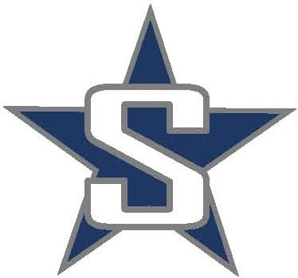
SOLDOTNA HIGH SCHOOL
BASEBALL 2018

2/28/2018 Wed Baseball Begins
4/20/2018 Fri @ Colony (4:00/6:30)
4/21/2018 Sat @ Colony (10:00/12:30)
4/24/2018 Tues vs Homer (3:00/6:00)
4/26-28/2018 Thurs-Sat @ JV Houston Tournament
4/27/2018 Fri @ Palmer (6:00 / varsity only – nonconference)
4/28/2018 Sat @ Wasilla (2:00 / varsity only – nonconference)
5/3/2018 Thurs vs Kodiak (3:00/6:00)
5/5/2018 Sat vs Kodiak (3:00/6:00)
5/7/2018 Mon @ Kenai (4:00/6:30)
5/9/2018 Wed @ Homer (3:00/6:00)
5/12/2018 Sat vs Palmer (11:00/2:00)
5/14/2018 Mon vs Kenai (3:00/6:00)
5/17/2018 Thurs vs Houston (3:00/6:00)
5/18/2018 Fri vs Grace Christian (6:00)
5/19/2018 Sat vs Wasilla (11:00/2:00)
5/24-26/2018 Thurs-Sat @ Regions (Homer)
5/31-6/2/2018 Thurs-Sat @ State (Anchorage)

