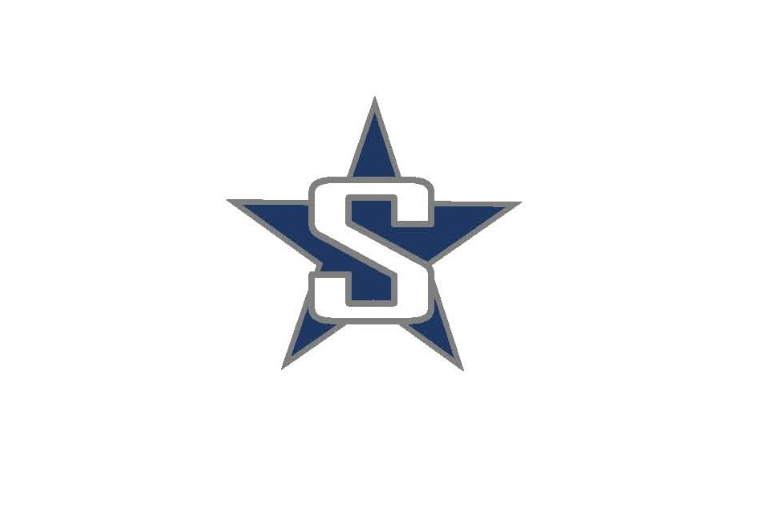
SOLDOTNA HIGH SCHOOL
WRESTLING 2017

9/27/2017 Wed Wrestling Starts
10/14/2017 Sat @ Luke Spruill Memorial (Kenai)
10/20/2017 Fri @ Homer Duals
10/21/2017 Sat @ Homer Rumble
10/27-28/2017 Fri-Sat @ Bartlett/South (Varsity)
11/3-4/2017 Fri-Sat @ Colony Invite
11/10-11/2017 Fri-Sat @ Peninsula Duals (Nikiski)
11/17-18/2017 Fri-Sat @ Lancer Smith Memorial (Palmer)
11/18/2017 Sat @ Kenai Jamboree (SOHI JV)
12/1-2/2017 Fri-Sat @ North/South Tournament (Soldotna)
12/8-9/2017 Fri-Sat @ NLC Region Championships (Kodiak)
12/15-16/2017 Fri-Sat @ State Championships (Anchorage)

